Dear Director,

My name is Ronald, and I am a Year 1 student at NUS. I have recently visited the Former Ford Factory and I found the visit to be an eye-opening adventure. From the visit, I learnt of a few new insights into life during and after the Japanese Occupation. However, I felt that there are some questionable points in the museum that could be better addressed. On your website, the information on the Former Ford Factory is “The Former Ford Factory was restored by the National Archives of Singapore and currently houses a permanent World War II exhibition on the war and its legacies.” As such, I would assume that from this information and my experiences, the Former Ford Museum is a war memorial for WWII.

Firstly, I would like to commend the use of colours in your exhibition. Each zone had its own distinct zone which best emphasised the mood of the period, such as red for Zone 3: Becoming Syonan, with the numerous acts of violence by the Japanese in Singapore. Also, props were used efficiently to convey messages. In Zone 1, newspaper articles were masquerading as aeroplanes to simulate air raids. The Sook Ching Massacre video was displayed on a lorry, presumedly used to transport hordes of young men to be executed. The use of camo nets was also interesting to signify the guerrilla warfare portion. These are just some examples of interesting props that I have spotted.

There was also a clear chronological flow to the exhibits. However, I noticed how there are some portions that should have been given much more emphasis as compared to other portions. For example, being a War Memorial in Singapore, I would expect that the exhibits to be mostly on war in Singapore. However, in Zone 2, the Fall of Singapore, the information about war in Singapore was mostly limited to the last portion. I understand the need of a backstory to bring in context, but I find that there is something wrong when more than half of the exhibition in the zone is on the backstory of why Japanese attacked, and on Malaya. There was hardly any information on defence strategies, how the battles went in Singapore other than it ended in 7 days. For an exhibition on war in Singapore, it feels empty when the MOE social studies textbook has more information on the battles. The surrender came abruptly after the corner, when I was expecting more information on the war. It is undeniable that information was plentiful, but the focus was not where I would expect it to be. With your space constraints, I would suggest reducing the backstory, and provide more information on Singapore. This would be more suited to your aim of this exhibition.

Also, I believe too much space was dedicated to Zone 4. I understand the need to talk about the legacies of war. However, I don’t think that it is necessary to bring in the entire stretch of the politics in Singapore. I find it necessary to just talk about the immediate problems the British had with the locals, and what were in desperate need, such as healthcare and food. Too much information was allocated to the problems and the communists, and that made Zone 3 (which should be the main highlight) a bit too small and lacking in information. Furthermore, the abundance of (less relevant) information made it hard for visitors to fully appreciate Zone 4, especially after a heavy Zone 3. I can safely say that the space allocated to Zone 4 does not match well with time spent there.

My suggestion is to remove some of the information dump that is currently present and move the surrender of the Japanese to the front of Zone 4. This frees up more space for Zone 3, which is currently a bit too small despite its significance in your aim of this exhibition.

Finally, to the main portion of Zone 3. This is where the main bulk of the exhibition should be, but there does not seem to be an equal allocation of space to it. The information provided was also inadequate to paint a complete picture of what happened there. Firstly, atrocities committed by the Japanese. As a war memorial, it is essential to tell visitors what happened there, with no censorship. Right now, information on these atrocities are only limited to one war, and visitors must spend time reading every single account on the screen at that war to understand completely how brutal the Japanese were. My suggestion is to fully utilise the Augmented Reality (AR) feature that is already being implemented. Show some images/animations into a pair of binoculars, such as young men being executed in a line on the beach (Sook Ching), Japanese kicking a child for not bowing low enough, some torture scenes, beheading someone and placing the head on a stick in public. Such scenes are sure to cause an adverse reaction from visitors. With the graphic scenes being in the binoculars, the scenes are not in public, and a warning can be issued to visitors before they see it and be made less lifelike to reduce the reactions. The aim of a war memorial in preventing war can thus be fulfilled.

Also, I would like to see an expansion of perspective such as from females and minority races beyond audio recounts. From observation, not many people chose to listen to the audio accounts, either from lack of interest or the audio earphones were in use. Some space being allocated for the recounts to be exhibited in prose would be better for visitors to read and experience their recounts. For example, this room (pictured below) is currently underutilised, and it can be filled with more information on life in Singapore. A visual recount of stories from various perspective would be the more interesting than what is present in the room. My suggestion is to move these exhibits to the front of Zone 4 as mentioned earlier and fill this room with more recounts with other perspective. For example, people who worked for the Japanese, business owners who had to make tough decisions during the occupation, and maybe even people from the Japanese administration. There could also be more visual recounts from females and minority races. All these would diversify the perspectives present in the museum.

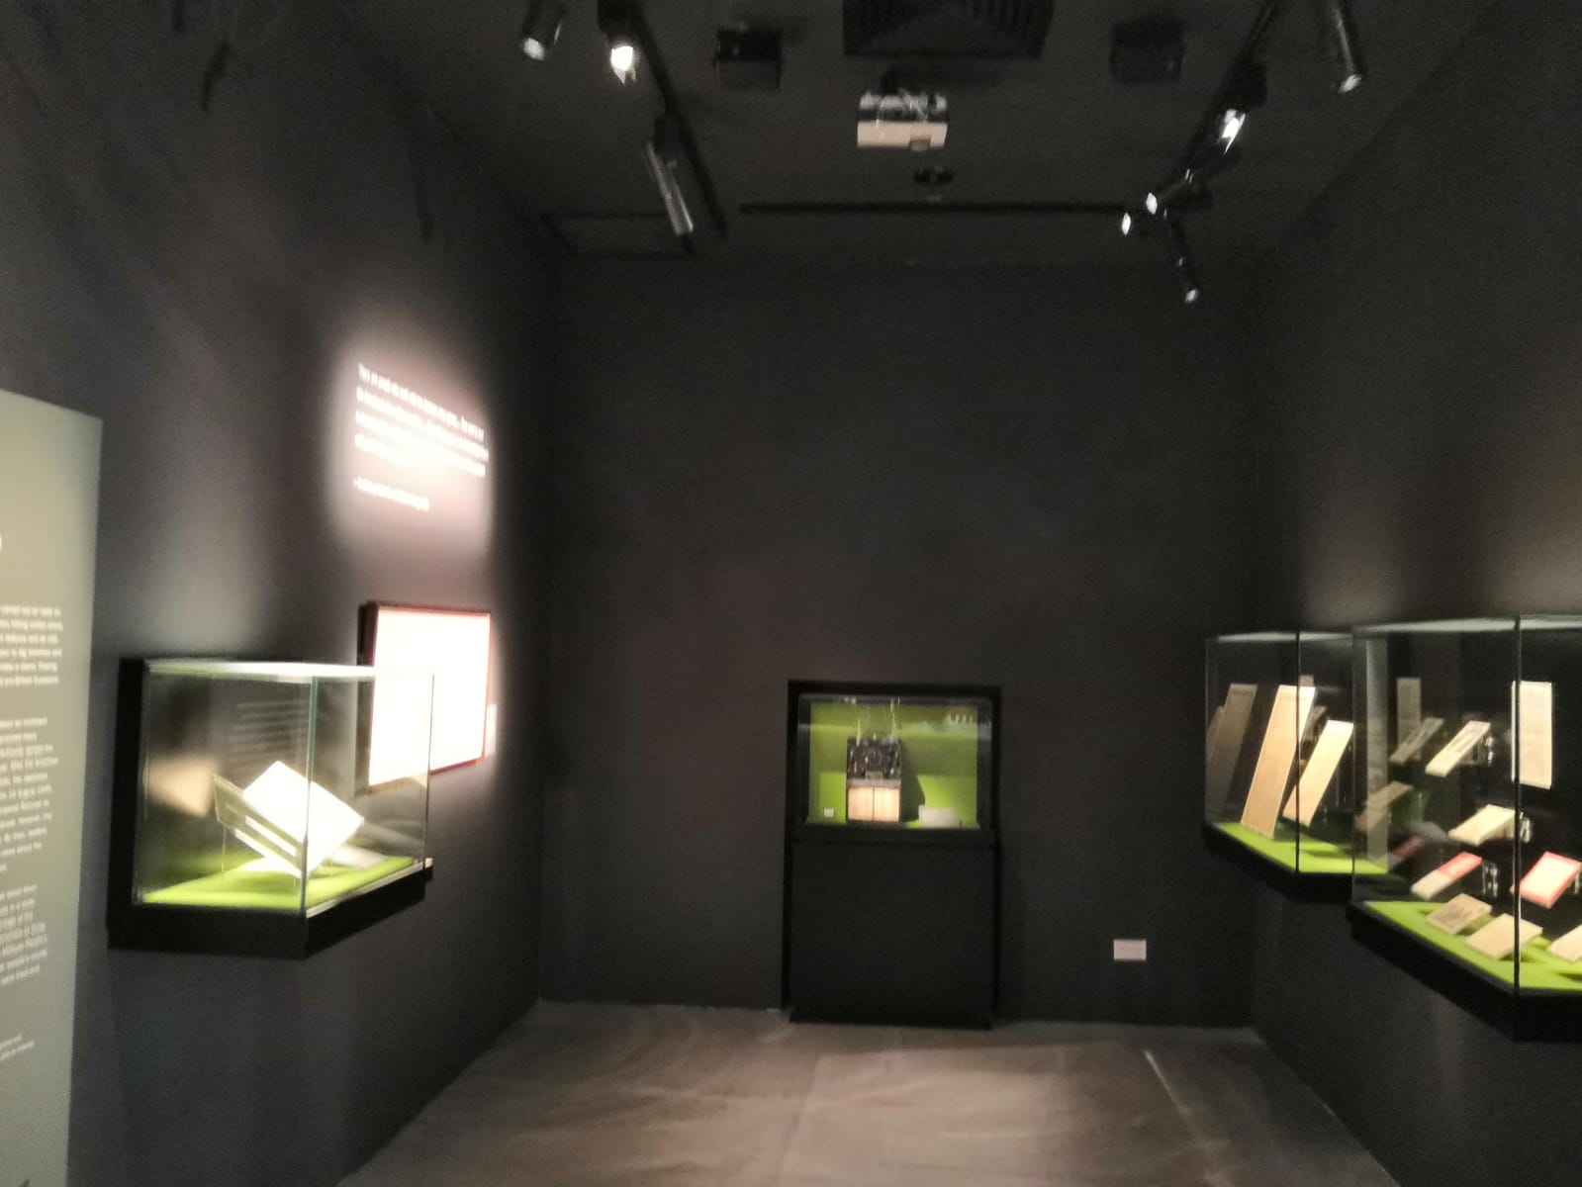

All in all, the Former Ford Factory was an eye-opening experience. However, information could be better organised, and space be allocated properly to areas with more relevant information (such as Zone 3). An increase in perspective of life during Japanese Occupation would also be good to tell the story of the Japanese Occupation.

Yours sincerely,

Ronald Toh

NUS Year 1 Student